ORGANISATIONAL DEVELOPMENT AND CORPORATE SERVICES DIRECTORATE

1. Directorate Overview
1.1 The Directorate is forecast to be on budget.

1.2 For the Directorate as a whole 10 (59%) performance measures are on target with 5 (29%) below target but within tolerance limits and 2 (12%) off target.

1.3 There are currently no red risks, but there are 11 amber risks for these areas.

2 Directorate Financial Performance

2.1 The Directorate is currently estimated to have a projected outturn position of £15.285 million, which is the same as the latest budget.

Service Variances
2.2 There are no anticipated variations to budget at the service level.

2.3 Outside of service budgets there are other matters worthy of note as follows.

Treasury Management

2.4 The Base Rate remains at 0.5%. Total investments at the end of the quarter were £61.4m with £7.5m of this being held in Money Market Funds. There were no significant changes to the investment portfolio during the quarter. The average rate of return has fluctuated at around 1.1% and variations are due to small changes in the rates available at the time of investing which are influenced by money market activity.

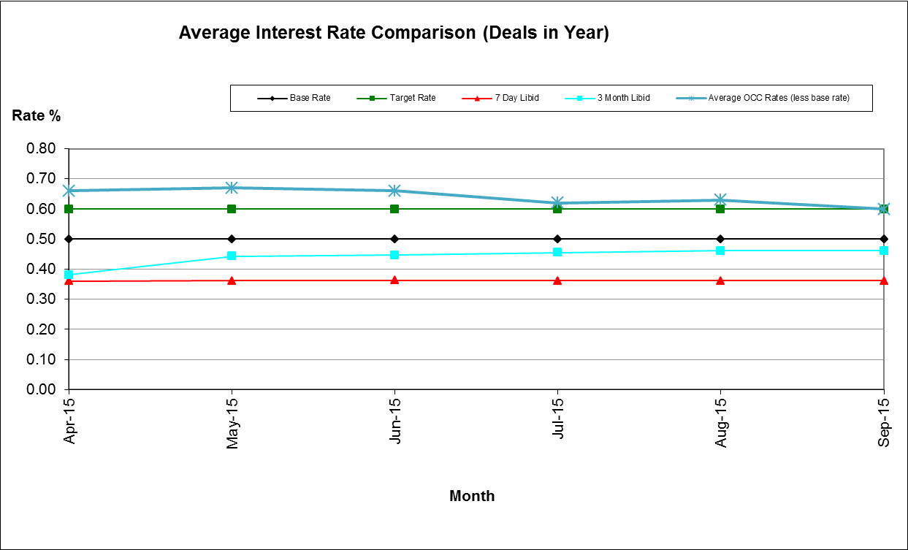

Housing Benefit Overpayments

2.5 The overall value of Housing Benefit Overpayments outstanding rose by £0.589 million over the quarter. The total value of Housing Benefits Overpayments as at 30th September was £6.214 million which is 16% higher than the equivalent 12 months previously. This increase is due to the extension of the Real Time Information data matching exercise and the Fraud and Error Incentive Scheme, both of which have increased the levels of fraud and error identification leading to an increase in identified overpayments. Just over £3m of the total outstanding relates to cases where there are currently no arrangements in place to clear the debt, these are subject to review. There is sufficient bad debt provision to cover this.

2.6 Despite the increase in identified Housing Benefit Overpayments, it is currently anticipated that the Council will be within the Local Authority error limits for the year.

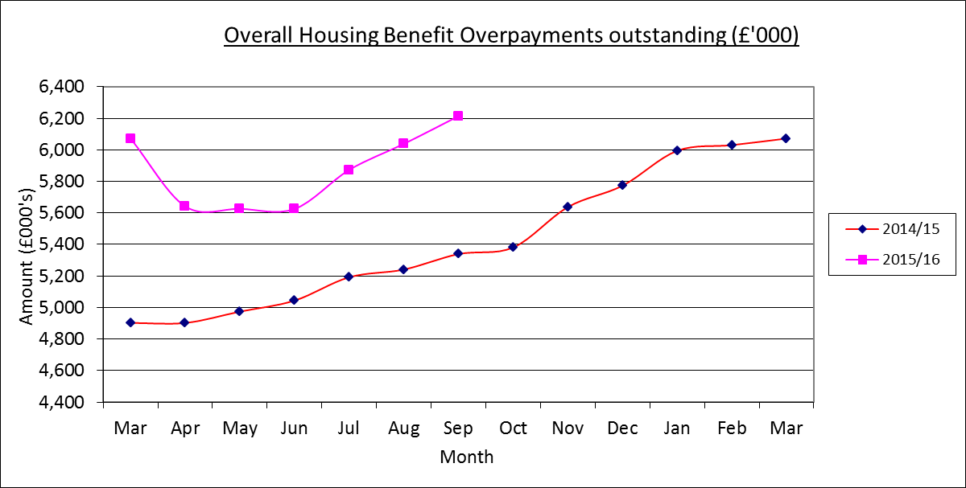

Business Rates Collection

2.7 Arrears of non-domestic rates carried forward on April 1st 2015 were £2.469 million (£0.854 million (25.7%) down on the corresponding figure 12 months earlier).

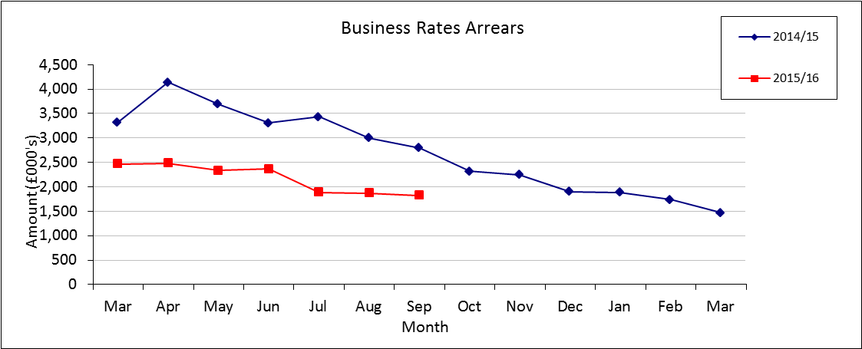

2.8 As at the 30th September arrears had fallen by 26.01% from £2.468 million to £1.826 million. An analysis of the £0.642 million shows that within this net movement there is £0.861 million in payments indicating a significant impact arising due to the new Courts Officer; the current arrears figure is almost 35% less than it was 12 months previously.

2.9 The 2015/16 collection rate was 58.18% at the end of the quarter against the profiled target of 57% and an improvement on the previous year's figure of 56.76%. The collection rate for 2014/15 has moved on from 98.80% at the end of 2014/15 to 99.13% six months later.

Council Tax Arrears Collection

2.10 Council Tax arrears (i.e. payments due for years 1993-94 up to 2014/15) carried forward on 1st April 2015 were £5.392 million, a 21.4% decrease on the corresponding figure 12 months earlier.

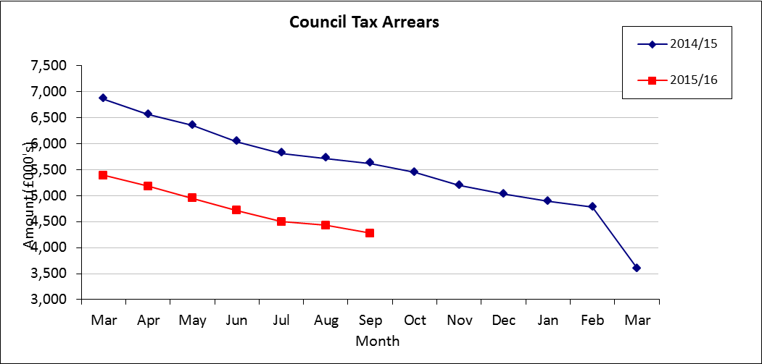

2.11 Over the first two quarters of 2015/16 arrears fell by £1.111 million to £4.281 million, a 23.8% improvement on the level of arrears 12 months before. Payments (net of refunds) received in the first half of the year totalled £0.964 million and write offs of £0.148 million have been processed.

2.12 The collection rate for 2015/16 at the end of the quarter was 57.01%. The corresponding figure 12 months previously was 57.04%. The collection of arrears has exceeded the end of quarter profiled target of 57% by £0.011 million. The collection rate for 2014/15 has moved on from 97.67% at the end of 2014/15 to 98.33% six months later.

3. Directorate Performance - Exceptions

Organisational Development

3.1 Days lost to sickness – Performance to September 2015 was at 3.06 days across the Council, just above the target of 3.0 days.

3.2 Percentage of employees with a disability – at September 2015, 8.3% of staff were identified as having a disability, against a target of 10%. The figures have remained fairly stable for the past year. The external Two Ticks Audit is due to take place in October and is expected to see another successful accreditation and to acknowledge new initiatives in awareness training, the employee assistance offer (OPTUM) and wider investment in Health & Wellbeing initiatives

3.3 Percentage of black and ethnic minority employees – The rate of BME applications for vacancies to the end of September stands at 21.39% while staff numbers remain stable at just under 7.5% of the workforce. Two engagement workshops were run in September to assist BME job seekers living in Oxford in gaining as awareness of the Council and what we have to offer as well as practical advice and guidance about how to overcome potential barriers around completing online or paper based application forms. 50% of attendees at these workshops were from BME communities and we received some useful feedback that will be fed into the current projects around how we recruit.

Financial Services

3.4 Percentage of rent collected – year to date performance at the end of September of 95.30% was marginally under the target of 95.50%.

3.5 Percentage of invoices paid on time – year to date performance at the end of September was 84.7% against a target of 98%. In-month performance has improved (90.6% in October) due to a concerted effort by the team to clear a backlog. A team structure is now in place with all team members in post which should have a positive effect going forward.

3.6 Time to process new benefits claims - As at the end of September performance was 17.48 days against a target of 14 days. During September there were a number of days processing lost due to system down time and issues with a few e-claims. The team were focussing on bringing all new claims up to date so that they could be allocated and looked at on date of receipt. This also meant some outstanding older claims were processed, adding to the number of days to process. Further process improvements have been introduced and for the last 3 weeks in October processing times for new claims are under 13 days. It is expected that this will now continue, and we are adding in additional stages of monitoring so that claims are closed at the earliest opportunity.

Business Improvement

3.7 Percentage of customers getting through first time on council main lines – performance as at the end of September was 94.2% against a target of 95%.

4. Risk Performance- Exceptions
4.1 There are no red risks in the Directorate but there are 10 amber risks detailed below. All these risks are currently being managed as part of day to day business activity and are not currently expected to rise to a level of red risk.

Business Improvement
4.2 Four amber risks have been identified in this area relating to the volume of ICT projects, the lack of resources to ensure resilience in the contact centre, not achieving savings targets and potential data protection breaches.

Law and Governance
4.3 Four amber risks identified in this area relate to the resilience of the service, ensuring secure permanent safe keeping of city archives, ensuring the electoral register is accurate and complete, ensuring ICT support is sufficient.

Financial Services
4.4 Two amber risks have been identified in this area relating to failure to recruit and retain key staff and treasury management risks.

